EVALUATING THE IMPACT OF LIGHT-RAIL ON URBAN GENTRIFICATION: QUANTIATIVE EVIDENCE FROM NOTTINGHAM’S N.E.T

  - Edward Dawes
ARUP

INTRODUCTION
Investment in light-rail transit (LRT) systems is often regarded in planning policy and empirical literature as one of the most effective measures to improve the performance and quality of public transport provision within urban areas. They are often assumed to help local authorities achieve various desirable transport policy objectives as the design and operational features provide advantages over more conventional forms of public transport investment. These advantages frequently include but are not limited to: faster and more reliable journey times; higher capacities, improved ride comfort, greater operational efficiency and reductions in localised air pollution (Vuchic, 2007; Dabinett, 1998).

Policy makers and planners alike advocate the ability of light-rail to drive improvements in accessibility to jobs and key services, in turn increasing the attractiveness of land in the areas around stations and route corridors (Vuchic, 2007; Dabinett, 1998). This increase in attractiveness can encourage gentrification to occur in the form of an inward migration of a higher socio-economic class of resident, attracting greater inward investment that revitalises and regenerates an area (PTEG, 2005; Knowles and Ferbrache, 2015). However, despite the viability of urban public transport schemes often being justified based on the evaluation of potential wider economic growth, the extent of the relationship between light-rail investment and land use in practice remains a highly-contested area of the literature. Empirical studies are often found to produce highly variable results across a range of different approaches (Mohammed et al, 2013; RICS, 2002).

This research identifies the crucial importance of developing an improved understanding of the relationship between light rail investment and urban gentrification as a crucial element of determining a future for light-rail investment in the UK (RICS, 2002; Knowles, 2007). If increases in the attractiveness of property and land around stations are evident through a growth in value, is this growth enough to encourage the socio-economic shifts associated with gentrification to take place? If so, light-rail and rapid transit investment could have a substantially greater impact on the economic and social prosperity of urban areas that is likely to have been neglected from the overall scheme appraisal. Improving the recognition of wider socio-economic changes that may arise as a result of light-rail investment will be crucial to develop mechanisms for funding and securing the future financial viability and feasibility of light-rail investment.

METHODOLOGY
There exists a consensus across the literature that gentrification has shaped social and physical aspects of neighbourhoods, but academics and researchers have yet to come to an agreement on how gentrified neighbourhoods should be identified (Hackworth, 2007). The adopted methodological approach was therefore devised taking account of recommendations from Hamnett (1984) regarding the need to account for physical, economic, social and cultural changes evident within the urban environment. The methodology was also devised following an assessment of the relevant strengths and weaknesses from a range of empirical investigations as well as the associated level of complexity and intensity of resource/data requirements (Mohammed et al, 2013; Atkinson and Bridge, 2005; Nesbitt, 2005).

Identifying Eligible Census Zones
It was necessary to determine the location and density of neighbourhoods with the potential to be gentrified over the ten-year period. Census zones were tested throughout the urban area based on their eligibility in the base scenario (2001). This would help determine the extent to which a change in indicators by zone or by stop on the N.E.T system could potentially indicate instances of on-going gentrification. Based on recommendations from Freeman (2005) and Hammel (1996) the decision was taken to identify eligible LSOA zones based on those that are within the lower quartiles for housing value and the upper quartiles for the proportion of lower level occupations, helping to quantify the extent of likely neighbourhood socio-economic status, income and the level of disinvestment experienced (Freeman, 2005). The census zones were then mapped based on their eligibility to gentrify and identified for further analysis (Figure 2.1).

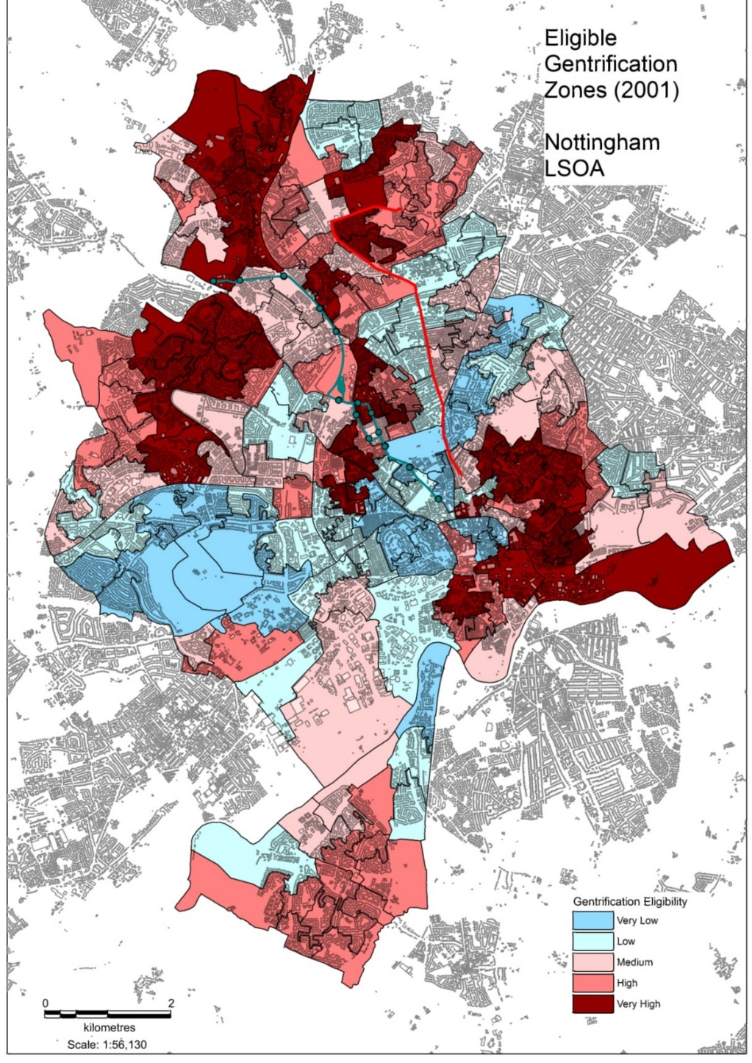
Figure 2.1 – Nottingham City Eligible Gentrification Zones (LSOA)

Measuring Gentrification
The lack of a consensual definition of gentrification (Smith, 1996), as identified in the literature review makes measuring gentrification difficult, and the need to develop a comprehensive understanding of these opposing definitions is important in devising a good methodological approach. One of the most prominent aspects of the gentrification process is the importance of capital values (production-side) and how accessibility changes the ‘rent-gap’ often reflected in the value of land/property prices (Smith, 1979). This is the more conventional understanding, and links strongly into the analysis of how light-rail influences the value of land through creating new accessibility constructs within the urban environment through faster and more reliable journey times. Data on median house prices by LSOA zone, price paid transaction data by postcode and rates of property turnover (transactions) were obtained and processed for the City of Nottingham to account for manifestations of gentrification in capital/production-based changes to the housing stock.

There was also the need to consider more demographic aspects associated with gentrification that can be indicated through changes in the socio-economic composition reflecting the changing preferences and tastes of consumers over time (Ley, 1980). Data was obtained from the census points that included the level of higher educational attainment (level 4), the proportion of higher and lower managerial occupations (NS-Sec) and the degree of owner-occupied housing (OCC). A list of all of the capital and socio-economic variables used are outlined in Table 2.1 below. All of these datasets were obtained for each census point 2001 and 2011 allowing a value of relative or percentage change (%) to be calculated. The median house price and land-registry data was available for every consecutive year between the census dates which provided a considerable level of additional clarity to some of the shorter-term impacts of the tram and significantly changed the overall conclusions of this study.

Gentrification was determined to be occurring when the percentage growth figure for most indicators within the census zone were higher than the total percentage change figure for the wider urban area over the same period (Nesbitt, 2005). The full impact of light rail in regenerating deprived areas could take several years to achieve (NAO, 2004). Therefore, accounting for time-based constraints was a crucial part of developing a robust methodology. Several key points in the N.E.T scheme lifecycle were covered in order to monitor changes. Through using data from the two census points, the study accounts for a time period that covers any likely land speculation that may occur in the three years prior to the scheme’s introduction as a result of land owners and property developers responding to potential future changes in demand (Hamnett, 1991; Knowles and Ferbrache, 2015). The timeframe also covers the scheme opening (2004) as well as a continual seven-year operational period up to 2011. The importance of these time-based considerations was adopted from on methodological recommendations from RICS (2002) and NAO (2004) based on analysis of the validity of results from previous empirical research.

Variable | Literature
Physical/Infrastructural
Empirical observations of shop units/new developments | Hammel (1996)
Capital
Changes in land values and house prices | Smith (1979)
Rates of property turnover | Smith (1979)
Socio-Economic
Educational Attainment (Level 4) | Freeman (2005)
Owner-Occupied Housing | Freeman (2005)
Higher/Lower Managerial Occupations | Freeman (2005)
Table 2.1 – Study Gentrification Indicators

Devising a Suitable Control Area
This study adopted a comparative methodology using spatial buffer analysis within GIS software allowing data obtaining to land use to be easily captured within relative walking accessibility of both the LRT corridor, and the devised control corridor. The method was adopted following recommendations from a recent report by UKTram that highlighted how future impact studies could devise similar control areas to isolate light rail’s impacts from other factors and temporal trends (Knowles and Ferbrache, 2015; Du and Mulley, 2007). In order to devise a suitable control area, it was necessary to select a corridor that had a similar proportion of what were deemed as: ‘gentrification attractors’ as a means of controlling for differing degrees of susceptibility of areas to gentrify (Chapple, 2009; Nesbitt, 2005; Freeman, 2005). This allows the methodology to better ‘control’ for the existence of light-rail establishing the transport mode operating along each corridor as the only potentially ‘attractor’ variable that is different. In order to quickly and efficiently compare the similarities between potential control corridors in the city, a small testing model was built within GIS.

There were several key area attractors that were identified from the literature and have been summarised in Table 2.2 along with the method used to account for them. These included the historical characteristics of an area which often found to make neighborhoods more attractive to potential gentrifiers (Nesbitt, 2005). The proximity to the city centre which links into classic gentrification theories of accessibility (bid rent theory) (Ley, 1980; Smith, 1979) and how gentrifiers have greater demand to be closer to cultural events and locations of jobs and other amenities in the city centre. The location to proximity to transport corridor acts as the control variable in this case, where each corridor will have suitable degree of transport provision (including proximity to major road corridors) with the only difference being that of the mode that is operated (LRT vs Bus). Finally, the proximity to schools (catchment areas) and healthcare services also helps to increase the attractiveness of an area as individuals value the greater proximity to these facilities, often making their use easier. Although less of a factor, previous research has found that proximity to green open space is also directly correlated with the likely demand for housing (Luttik, 2000).

Variable | Method used | Literature
Historical Value | Spatial buffer to measure the average % of housing built pre 1950 in each corridor. | Nesbitt, 2005
Proximity to the City Centre | The route length of the N.E.T corridor and the control corridor are of similar length and both originate from the same point in relation to the city centre | Nesbitt, 2005; Smith, 1979; Ley, 1980
Control Variable: Transport Accessibility | Focal point of the study. N.E.T corridor is dominated by light-rail, while the other is a conventional bus route operating at a similar frequency | Nesbitt, 2005
Proximity to other facilities | Spatial buffer to measure the total number of schools and healthcare facilities within relative accessibility of each route (e.g GPs, Doctors Surgeries) | Florida, 2015
Proximity to green/open space | Spatial buffer to measure total instances of parks/green space | Luttik, 2000; Wu et al, 2014
Table 2.2 – Gentrification Attractors

It was also necessary to choose a control corridor that also contained broadly similar geo-demographic characteristics to that of the tram corridor (Figure 2.2). This was achieved through mapping each zone in the city region to the eight output area classifications (OACs) from the census (ONS, 2011). Although the OACs of each zone did not account as a direct gentrification attractor, the classifications helped to account for differences in the socio-economic status, level of ethnic mixing and level of deprivation extent in each corridor. OACs were compared between the N.E.T corridor and the control corridor as a total % proportion of coverage. Table 2.3 shows the results from the model of the control route and the two next best alternatives that were identified. The routes were considered on the number of indicators that were the closest match to that of the tram corridor.

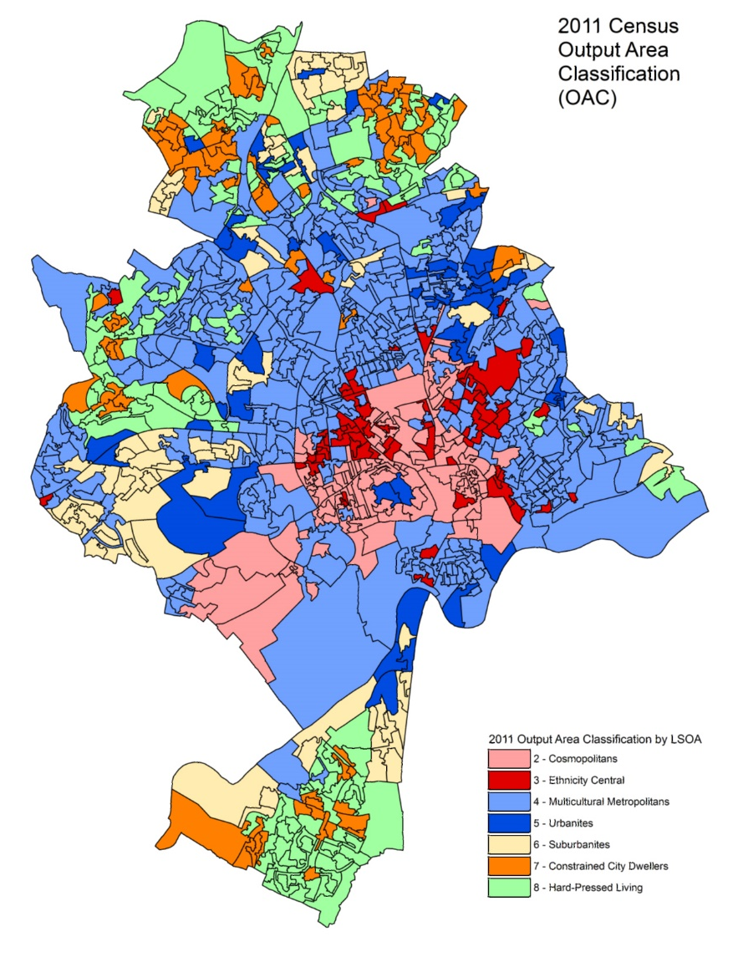
Figure 2.2 - 2011 Nottingham City Output Area Classification by LSOA

Indicators | N.E.T Route | Control | Next Best Alternative 1 | Next Best Alternative 2
 | N.E.T Tram | NCT 15/16 | NCT 89 | NCT 17
% Cosmopolitans (2) | 9% | 14% | 19% | 15%
% Ethnicity Central (3) | 12% | 8% | 8% | 9%
% Multicultural Metropolitans (4) | 64% | 52% | 38% | 51%
% Urbanites (5) | 6% | 6% | 10% | 8%
% Suburbanites (6) | 3% | 2% | 1% | 4%
% Constrained City Dwellers (7) | 2% | 5% | 10% | 2%
% Hard-pressed living (8) | 4% | 12% | 13% | 12%
% of housing built pre 1950 | 58% | 49% | 49% | 58%
Further/Higher Education | 8 | 5 | 7 | 6
Secondary Education | 2 | 3 | 2 | 4
Primary Education | 14 | 19 | 13 | 15
Healthcare/Medical | 11 | 12 | 15 | 13
Park/Woodland | 57 | 68 | 57 | 74
Similarity | - | 6/14 | 4/14 | 3/14
Table 2.3 - Route model characteristic comparisons

DISCUSSION

Objective 1
The results from the spatial analysis of gentrification indicators for the tram corridor and the wider urban area are summarised in Table 3.1 below. It was found that the N.E.T corridor in aggregate underperformed against the wider urban area on all of the capital and socio-economic gentrification indicators measured. However, disaggregating the results for each individual stop helped to identify how the growth in these variables varied spatially along the route, highlighting the importance of the assessment of locality when analysing the potential economic impacts of transport investment (Du and Mulley, 2007). The fields highlighted in green represent the use of the governing method, determined where specific indicators have increased at a greater rate than that of the wider urban area over the same period, often used as a measure for pre-determining instances of gentrification through differing rates of urban change (Freeman, 2005; Atkinson, 2000).

The highest growth in capital indicators, based on average price paid for housing (Smith, 1979) was focused between The Forest and Basford with increases ranging from 82% to 95% between 2001 and 2011 that were in some cases considerably higher than the average observed for the city over the same period. This indicates at the potential for gentrification to occur within these neighbourhoods in the future, particularly as these were identified as areas that were eligible (Laska et al, 1982; Smith, 1979). However, upon analysis of other socio-economic variables that would be indicative of a migration of the more affluent ‘gentry’ into these areas, it was found that the tram corridor underperformed on nearly all accounts including changes in educational attainment, occupations and the proportion of self-owned properties. The results suggest that although there is notable evidence of stronger growth in housing value, this is not necessarily causing gentrification to occur.

Tram Stop | Average Price Paid | Educational Attainment (L4) | Higher Level Occupation | Lower Managerial Occupation | Self-owned housing
Trent University | 46% | +4.6% | -0.5% | -2.4% | +2%
High School | 47% | -4.9% | -0.3% | -2.9% | -2%
The Forest | 89% | -1.2% | -0.2% | -1.8% | -1.9%
Hyson Green Market | 87% | -0.6% | -0.1% | -1.4% | -1.6%
Noel Street | 86% | -1.4% | -0.5% | -1.8% | -1.8%
Radford Road | 88% | +0.1% | +0.1% | -1.2% | -2.3%
Beaconsfield Street | 95% | -0.3% | +0.1% | -1.3% | -2.3%
Shipstone Street | 82% | +1.2% | +0.8% | -1.3% | -2%
Wilkinson Street | 84% | +1.4% | +0.7% | -1.0% | -1.8%
Basford | 92% | +4.4% | +2.3% | -0.1% | -2.4%
David Lane | 72% | +4.5% | +2.8% | +0.8% | -0.8%
Highbury Vale | 70% | +5.2% | +2.6% | +2.6% | +2%
Cinderhill | 66% | +5.7% | +2.6% | +2.7% | +1%
Phoenix Park (P&R) | 57% | +5.7% | +2.6% | +2.7% | +1%
N.E.T All Stops | 65% | +2.5% | +1.2% | -0.5% | -0.8%
City of Nottingham | 73% | +4.2% | +2.5% | +1.2% | +0.8%
Table 3.1 - Change in Gentrification Indicators by N.E.T Stop (2001 – 2011)

Average Price Paid
The strongest growth in average price paid was between The Forest and Basford for which growth figures of between 86%-95% over the monitored period were observed, indicating a potential premium paid on properties in these areas. The stops are located in the adjacent inner-city neighbourhoods of Forest Fields and Hyson Green, an area identified as eligible for gentrification to occur. These are areas that have previously suffered from areas of long-standing unemployment, increased poverty, social exclusion and a persistent negative social image (JR, 1999). These areas have the largest ethnic minority population in the city and have a varied range of different cultures. Hyson Green is second largest area of the city for retail after the city centre and has a thriving local economy. It is important to consider these external aspects when considering the impact on the influences behind observed increases in house prices (Mohammed et al, 2013).

Figure 2.1 represents the other areas of strong growth in housing value that have taken place across the city. The map shows that a lot of the growth has occurred within the inner city although the distribution is very fragmented with an equal number of high growth zones (138-218%) and low growth zones (-30-50%). Other clusters of growth are located in the western suburban areas of the city (Wollaton and Beechdale) and also in the south of the city (Clifton and Beeston). The emerging themes from these findings link to production-based theories of gentrification which state that the process is more likely to occur within the inner city based on the previous conditions of the housing stock and the proximity to the city centre. Originally, many researchers would have regarded changes in housing value as one of the strongest indicators that gentrification is occurring, but since the field and debate has developed, we now understand that the existence and correlation with other socio-economic indicators are just as important and that a combination of factors are often needed (Hamnett, 1991).

Educational Attainment
The highest increases in the level of educational attainment (level 4) were more focused in areas close to or within the city centre itself, particularly in areas surrounding the University of Nottingham, indicating that the socio-economic classification of these neighborhoods has been changing gradually over the monitoring period due to a residing student population. There was weak evidence however to suggest this has occurred within gentrifiable areas of the inner city along the N.E.T route with observed changes of between +1.4 and -4.9% across these stops. This is further highlighted in Figure 3.2 which represents where these changes have been clustered. Most of the change is concentrated towards the south of the city in Beeston and Clifton, as well as the suburban areas in the east and north of the of the city. Major increases in educational attainment are an excellent indicator of gentrification as they often directly correlate to socio-economic status meaning these results show little evidence of social change and displacement of existing communities (Ley, 1980).

Higher/Lower Managerial Occupations
LSOA zones closer to the city centre experienced a decline in the proportion employed in higher managerial occupations. Trent University to Noel Street experienced minor decreases in the proportion of people employed in this classification of between -0.5% and -0.1% over the 10-year period. Analysis revealed that from areas around Noel Street, the higher managerial occupations increased almost progressively with distance from the city centre. Areas surrounding Radford Road and Wilkinson Street saw modest increases of between +0.1% and +0.8%, however in more suburban and affluent areas of the city such as Highbury Vale and Cinderhill occupations grew by as much as 2.6% and 2.7% which were significantly higher than the city wide average. The level of lower managerial occupations showed a similar pattern, although the decline in these types of occupations were more spread along the route. All stops within the inner city between Trent University and Basford experience declines ranging from -2.4% to -0.1%. After which point the occupation proportions in accessible zones increase dramatically to around 2.1-2.6%. The growth of occupational proportions was also considerably varied across the urban area with substantial increases in the southern areas of the city in Beeston and Clifton as well as pockets in the north of the city to the west of Bulwell which are reflected in the results for Phoenix Park, Cinderhill and Highbury Vale stops on the N.E.T (Figure 3.3). The concentration of these changes across the urban area show a similar spatial distribution to that of the level of educational attainment highlighting the correlation that often exists between the level of education and income. Occupation is a key gentrification indictor in this study as it acts as a determinant of how household incomes are likely to have changed over the period, replacing the lack of readily-available income datasets that are not available in the UK, but have been used widely by similar gentrification studies in the US (Chapple, 2009).

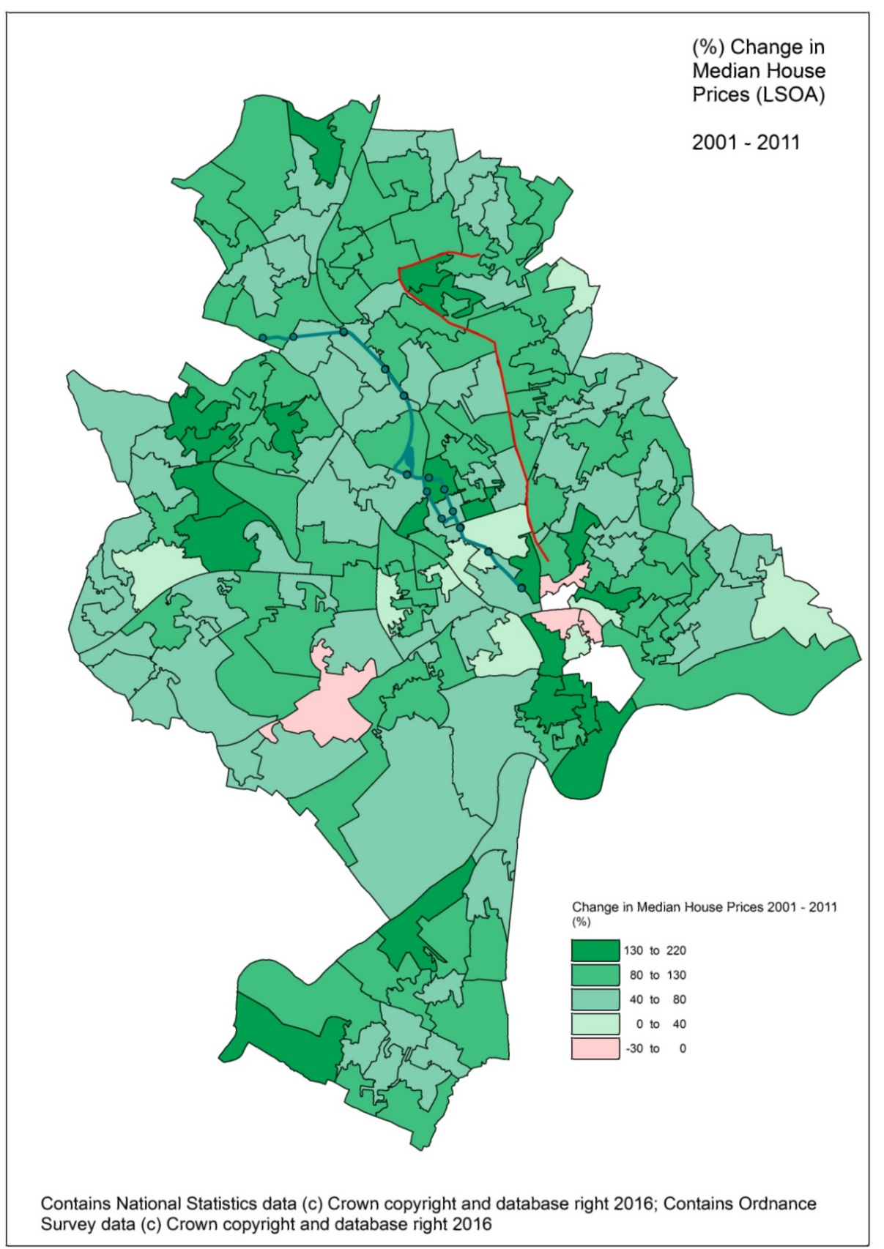
Figure 3.1 - % Change in Median Housing Value by LSOA Zone (2001 - 2011)

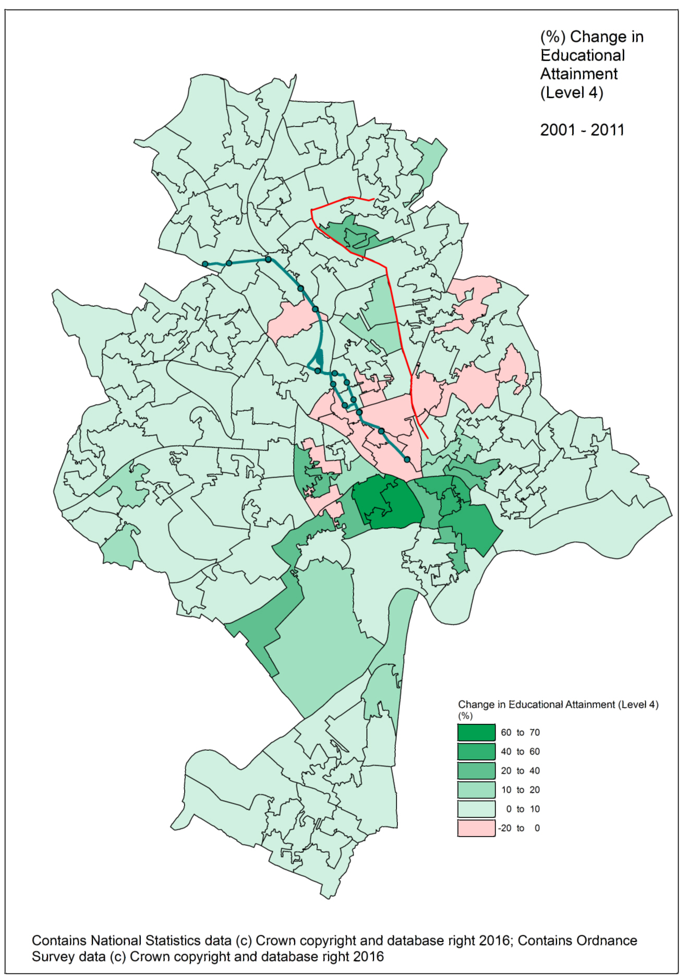
Figure 3.2 - % Change in Level 4 Educational Attainment by LSOA Zone (2001 - 2011)

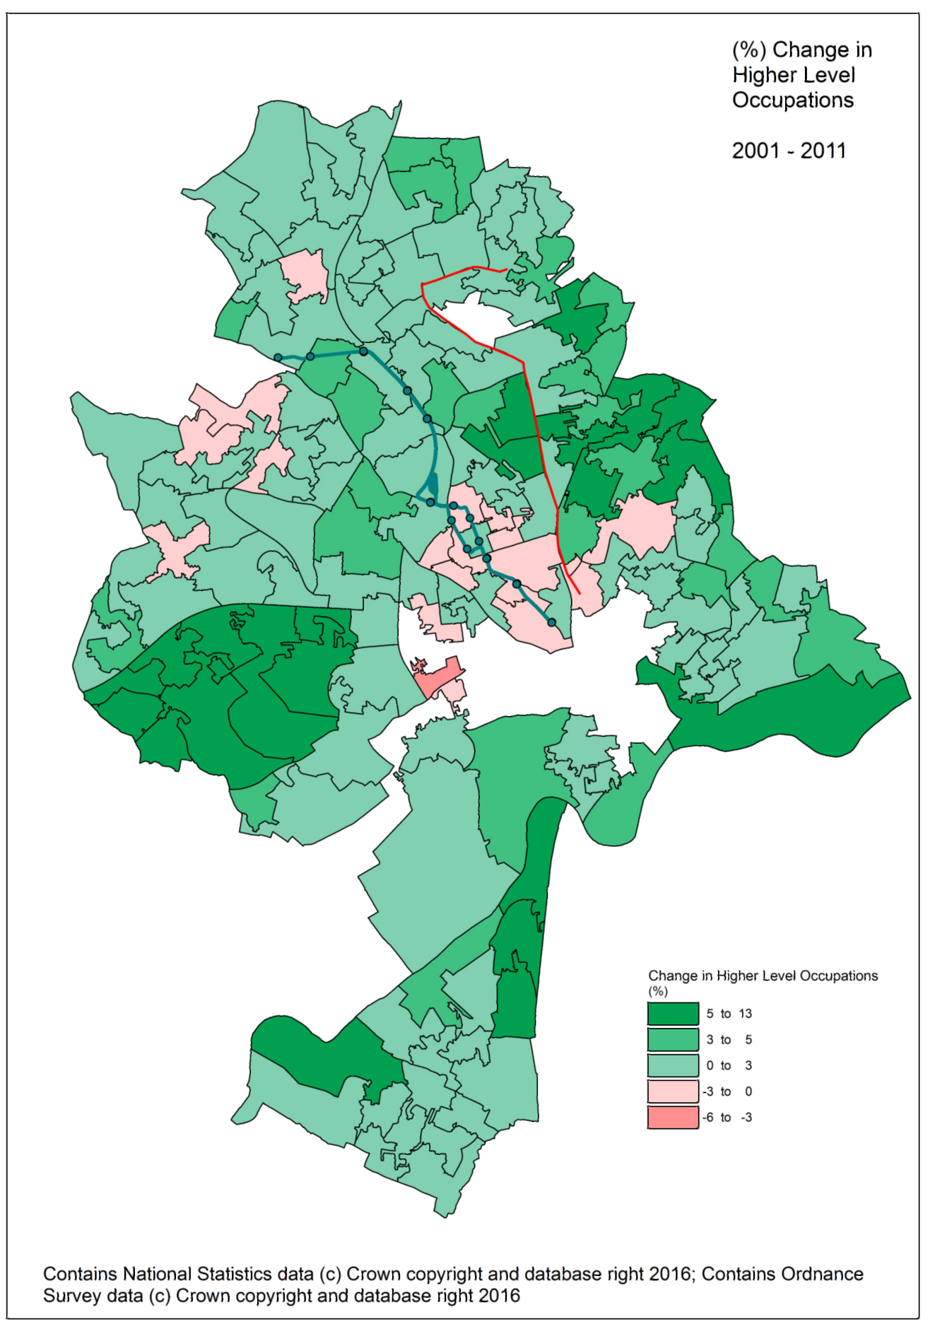
Figure 3.3 - % Change in higher and lower professional occupations by LSOA zone (2001 – 2011)

Objective 2

Comparison of Capital Indicators of Gentrification
The results from comparing the changes in average price paid data and rates of property turnover for the tram corridor against the control corridor between 2001 and 2011 are included in the summary table below (Table 3.2). It was found that in aggregate, the light-rail corridor significantly underperformed against the control corridor and the wider urban area on all of the capital indicators measured. Average prices in the control corridor increased by 75%, higher than the city average of 73% while prices in the tram corridor increased by just 65%. In addition to this, although all areas experienced a decline in the rate of property turnover (number of recorded annual transactions) the tram corridor decreased at a faster rate (-62%) to that of the control corridor (-41%) and the wider urban area (-53%). This highlights that there is a considerably lower amount of people moving into areas along the tram corridor.

 | N.E.T Corridor (LRT) | Control Corridor (Non-LRT) | City of Nottingham
Average Price Paid (£)
2001 | 62380 | 73509 | 68026
2011 | 102677 | 128366 | 118018
% Change | 64.60% | 74.63% | 73.07%
Rate of Property Turnover (transactions per annum)
2001 | 1,175 | 445 | 5,627
2011 | 441 | 263 | 2,637
% Change | -62% | -41% | -53%
Table 3.2 – Change in capital indicators of gentrification by study area

Analysing the change in these capital indicators to an index to measure growth annually between 2001 and 2011 revealed a different picture however (Figure 3.4). It was discovered that the relative growth in housing value in the N.E.T corridor rose slightly greater than that of the comparator areas during the pre-scheme phase between 2001 and 2004, potentially indicating how land values and speculation by property developers helped to drive up prices before the scheme’s opening (CTOD, 2008). After the introduction of N.E.T in 2004, housing value in the corridor grew at an even more substantial rate, potentially indicating how the property market responds to the introduction of the tram in the shorter term. However, from 2006/7 onwards, the value of housing in the N.E.T corridor fell at a considerably greater rate than the other comparator areas, which appeared to remain more buoyant during the economic recession. Due to the declines in growth over this period, the N.E.T corridor actually ended up being the lowest performer in terms of overall growth over the ten-year period. Although the change in the rate of property turnover varied yearly in each of the corridors, there was an overall decreasing trend for each corridor (Figure 3.5). Property turnover in the N.E.T corridor decreased marginally between 2002 and 2004 possible due to the disruption caused by the scheme’s construction, while the control area increased rapidly. Interestingly, after the beginning of operation in 2004, there was a sharp decline in the rate of property turnover, but from 2005 onwards this grew rapidly to almost draw in-line with that of the control area for the same period. As to be expected, the economic recession in the post-2007 phase caused the rate of transactions to decline further for both corridors, although this again was more substantial in the light-rail corridor.

Figure 3.4 - Change in Average Price Paid 2001 - 2011 (Index = 100)

Figure 3.5 Change in Property Turnover/Transactions 2001 - 2011 (Index = 100)

Comparison of Social Indicators of Gentrification
The analysis of the change in social indicators of gentrification revealed that there was evidence to suggest that the tram corridor had underperformed on all accounts. Table 3.3 highlights how the growth in the number of residents along the control corridor increased by 7.22% in the control corridor and 7.10% in the wider urban area, almost 5% higher than that of the tram corridor. Similar results were found for all of the other indicators including changes in socio-economic occupations, where the tram corridor increased by 1.22% comparable against the control corridor of 2.25% and the wider city of Nottingham at 2.52%. Lower managerial occupations increased in comparator areas, but decreased by -0.48% in the tram corridor, with a similar pattern observed for the change in the number of residents who directly own their property.

Change 2001 – 2011 (%) | N.E.T Corridor | Control Corridor | City of Nottingham
Educational Attainment (Level 4) | 2.54% | 7.22% | 7.10%
Higher Level Occupations | 1.22% | 2.25% | 2.52%
Lower Managerial Occupations | -0.48% | 1.91% | 1.17%
Self-Owned Housing | -0.77% | 1.82% | 1.67%
Table 3.3 - Change in socio-economic indicators by study area

These findings are a major component of answering the overall research aim of this study. Although stronger evidence exists that is suggestive of gentrification in the analysis of capital variables, defining these changes can only be done when a combination of both capital and socio-economic variables are observed on all accounts (Hamnett, 1991). However, unlike the capital variables analysed in section 3.2.1 the socio-economic data was not available on an annual basis, meaning that short-term trends may have yielded different results.

Comparison by N.E.T Stop
To increase the detail of the comparison, individual stops were compared between the control corridor and the tram corridor based on the similarity of gentrification precursors and distance from the city centre. As gentrification is more likely to occur within inner-city areas, it is important to ensure that both stops within each corridor have a similar competitive position to each other. Four different stops with different land use characteristics were compared along each corridor, which are outlined in Table 3.4.

Stop Name/s | Area Description | OA Classification
Trent University (LRT)  Huntingdon St (Control) | High density townhouses – city centre neighbourhood | Cosmopolitans
Beaconsfield Street (N.E.T)  Bernard Street (Control) | High density terrace housing – inner city neighbourhood | Multicultural Metropolitans
Basford (N.E.T)  Ring Road (Control) | Medium density semi-detached housing – inner city neighbourhood | Multicultural Metropolitans
Cinderhill (N.E.T)  Gala Way (Control) | Medium density detached housing - suburban neighbourhood | Urbanites/Suburbanites
Table 3.4 – N.E.T/Control corridor locality characteristics

The results found that in two out of the four localities compared, the control area significantly outperformed the tram corridor on nearly all of the gentrification indicators measured (Table 3.5). The control area stops within the inner city seemed to have greater competitive position over the tram with nearly all of the gentrification indicators showing greater levels of positive change. Comparisons in more residential suburban areas of the city (i.e. Basford and Cinderhill) it was observed that the two corridors seemed to have similar levels of competitive growth across the measured gentrification indicators. The score for each stop has been highlighted in the final column. The results further highlight how the existence of the tram has a limited influence on encouraging positive socio-economic changes associated with the urban gentrification process.

 | Average Price Paid | Property Turnover Rate | Educational Attainment (L4) | Higher Level Occupations | Lower Managerial Occupations | Self-Owned Housing
Trent University (N.E.T) | 46.5% | -66% | +4.6% | -0.5% | -2.4% | +2% | 1
Huntingdon Street (Control) | 78.2% | -5.6% | +8.5% | -1.0% | -1.9% | +5.5% | 5
Beaconsfield Street (N.E.T) | 95.2% | -70% | -0.3% | +0.1% | -1.3% | -2.2% | 0
Bernard Street (Control) | 107.8% | -39% | +2% | +2.4% | +2.6% | +1% | 6
Basford (N.E.T) | 92% | -60% | +4.4% | +2.3% | -0.1% | -2.4% | 3
Ring Road (Control) | 70% | -42% | +1.8% | +1.4% | 0.5% | +5% | 3
Cinderhill (N.E.T) | 66% | -50% | +5.7% | +2.6% | +2.7% | +1% | 3
Gala Way (Control) | 53% | -58% | +6.7% | +2.7% | +1.6% | +3% | 3
Table 3.5 - Change in Gentrification Indicators by locality

Objective 3

Positive/Negative Characteristics of Light Rail
The online survey of property developers in the Nottingham city region revealed that the most attractive aspects of LRT that will drive positive price increases is the mode’s ability to bypass traffic congestion (8/9 respondents) and provide good levels of accessibility (7/9 respondents). Studies have highlighted that due to the growth in road traffic in recent times many city centres have become increasingly less accessible, particularly during peak times due to traffic congestion. The ability of light-rail to bypass congestion through providing dedicated rights of way (ROW) and priority at junctions helps greater levels of accessibility to key services make LRT considerably more attractive than competing modes, particularly for travel within urban areas (Docherty et al, 2009; Bowes and Ihlanfeldt, 2001). This links into how improvements in access to jobs and services creates a ‘rent gap’ within the urban environment (Smith, 1979). Despite this, faster and more reliable journey times were less of a factor than greater accessibility with just 5 out of 9 respondents stating this as a factor, highlighting how in some cases (particularly in off-peak periods) that the tram may not offer any competitive journey time savings or additional levels of reliability.

Figure 3.6 - Estate Agency Survey: LRT characteristics in determining land value increase

Contrastingly, negative issues associated with light-rail operation can also have a predominantly negative effect on properties located directly along the tram route (Bollinger et al, 1998). It was found that the impact of noise and vibrations from trams was a dominant factor in determining any likely decreases in value along the tram corridor (5/6 respondents) as well as the visual intrusion (4/6 respondents) imposed by the overhead catenary, the tram units and station/stop infrastructure. The reduction in provision for car travel was also a significant factor as tram infrastructure may often reduce the number of available lanes and make travelling by private car considerably more challenging.

Figure 3.7 - Estate Agency Survey: Negative characteristics of LRT in determining land value

Modal Perspectives
Further results from the online survey highlight how the facilities for the private car play a greater role in determining property value than the existence of any other transport mode (Table 3.6). The weighted average of responses was 8.13 for car parking availability and 7.73 for good road connections. Proximity to the tram was highlighted as the third most important attribute however (5.60) this was considerably lower than the car-based attributes.

 | Not Important | Slightly Important | Moderately Important | Highly Important | Most Important | Weighted Average
Proximity to a tram stop | 7% | 27% | 47% | 20% | 0% | 5.60
Proximity to a bus stop | 13% | 40% | 47% | 0% | 0% | 4.67
Car parking availability | 0% | 7% | 13% | 47% | 33% | 8.13
Good road connections | 0% | 0.00% | 33% | 47% | 20% | 7.73
Good walking/cycling facilities | 20% | 27% | 53% | 0% | 0% | 4.67
Proximity to a train station | 13% | 33% | 40% | 13% | 0% | 5.07
Table 3.6 - Importance of transport attributes in determining property value

Further analysis of the change in modal split for journey to work from the 2011 census in each corridor further revealed evidence about the competitive position of each mode in the city relative to LRT (Table 3.7). Despite evidence of car use in the N.E.T corridor decreasing by -7.53% comparable to more modest increases in the control corridor and wider urban area between 2001 and 2011, the average share of private car for trips in 2011 still remains high (21.55%). Interestingly, the statistics suggest that the bus remains more competitive than the tram, even along the tram corridor, accounting for 9.82% of trips, comparable to just 3.33% for the tram. These results highlight that the tram may have a limited attractiveness and competitive position against more conventional modes, even directly within the corridor itself. These findings run counter to research that has identified that perceptions of LRT are significantly greater than bus, which are likely to encourage a ‘step-change’ in patronage over time (PTEG, 2005). Comments made by respondents in the survey emphasised how the limited coverage of the route actually reduces its use and spatial coverage, highlighting why positive modal shifts may have been limited.

Mode | N.E.T Route | Control Route | City of Nottingham
2001
Av % tram | 0.03% | 0.02% | 0.05%
Av % bus | 7.65% | 7.56% | 5.14%
Av % car | 29.08% | 26.64% | 23.09%
Av % walk | 5.88% | 4.98% | 4.80%
2011
Av % tram | 3.33% | 0.92% | 1.15%
Av % bus | 9.82% | 12.93% | 11.19%
Av % car | 21.55% | 26.46% | 25.97%
Av % walk | 9.33% | 9.16% | 8.31%
Change 2001 - 2011
Av % tram | 3.30% | 0.90% | 1.10%
Av % bus | 2.17% | 5.37% | 6.05%
Av % car | -7.53% | -0.18% | 2.88%
Av % walk | 3.45% | 4.18% | 3.51%
Table 3.7 - Change in journey to work by mode (2001 - 2011)

CONCLUSIONS
This investigation has attempted to determine the impact that the operation of a light-rail system has had on urban regeneration in Nottingham through conducting a comparative spatial analysis methodology that measures changes to capital and socio-economic-based indicators of gentrification occurring within walking accessibility of the tram corridor, a devised control corridor and the wider urban area.

The analysis revealed evidence to suggest that light-rail in Nottingham has little impact on the emergence of wider demographic and socio-economic shifts often associated with urban gentrification, despite operating through areas of the city previously identified as eligible (Hammel and Wyly, 1996). The tram corridor significantly underperformed against the control area and the wider urban area on nearly all of the demographic and socio-economic indicators measured making theoretical ties between LRT and urban regeneration questionable (Young, 2007). It is controversial to suggest whether these are positive or negative findings. On the one hand, gentrification can help regenerate and revitalise areas of the inner city helping to drive greater economic growth, reduce localised crime and improve the standard of living (Freeman, 2005). However, on the other hand these results suggest that LRT investment does not exacerbate social inequality by causing existing residents to relocate (Knowles and Ferbrache, 2015; Vandergrift, 2006). Evidence from empirical observation of the type and extent of local amenities, businesses and new housing developments also mirrored these findings, with evidence of investment in the control corridor and significant underinvestment in the N.E.T corridor.

This study did however find evidence to suggest that the existence of light-rail helps to marginally increase the attractiveness of housing around particular stops, reflected in the rate of housing price growth over a seven-year monitoring period between 2001 and 2008 (5-10%). This is probably caused by the benefits of improved levels of accessibility to jobs and services located within the CBD which broadly mirroring findings found in other similar empirical studies (Ovenell, 2007; Weinstein and Clower, 1999). These increases were not distributed evenly along the corridor however and instead were found to be clustered around high density residential areas within the inner-city including The Forest, Hyson Green and Basford. The variability of findings by locality are similar to those found in Sunderland in a study by Du and Mulley (2007) on the Tyne and Wear metro, further strengthening the requirement to greater assess locality when appraising the economic benefits from these types of transport investments.

Further analysis into the cause of these results suggest that despite the tram encouraging a reduction in car use within the immediate corridor, the N.E.T system still remains under strong competition from the private car even for most urban journeys, severely limiting its attractiveness and ability to encourage these wider socio-economic changes over time (Lee and Senior, 2013). It was found that facilities for the private car including the availability of parking and proximity to major road corridors remained the most important attributes in determining the attractiveness of property, potentially indicating why the control corridor outperformed the tram corridor in this study.

Policy Recommendations and Further Research
Despite the results from this study suggesting that light-rail has a minimal impact on urban gentrification and regeneration, there still remains a need to continue to develop and strengthen this area of research, particularly in the context of UK light-rail investment. Some of the findings from this study and other similar studies suggest how investment in light-rail helps to marginally increase the value of land within certain areas of the corridor which could potentially form an economic base upon which socio-economic changes could take place at later stages in the scheme lifecycle (Waine, 2015; Du and Mulley, 2007). This recommendation is especially relevant as effects from LRT investment may not always be immediate and may take several years of well-established operation to come to fruition (Ovenell, 2007; RICS, 2002). Larger metropolitan areas in the UK are progressively moving towards higher population densities and greater levels of city living, for which the private car may become less attractive for urban-based trips due to lack of access and issues with traffic congestion, potentially causing a shift in travel behaviour (Litman, 2015).

The results from this study also highlight how light-rail has potential to create land value uplift that may not be reflected accurately in the existing WebTAG guidance. Developing a better understanding of the level of this interaction in the UK could permit development of alternative sources for funding including local developer subsidies, betterment tax and accessibility contributions (Medda, 2012; Knowles, 2007). These funding mechanisms could be used as a means of making light-rail a more financially viable option in the short-term for local authorities to invest. Government and local authorities need to establish better ex-post monitoring and assessment of not only the economic but also social changes that arise from light-rail schemes operating in the UK (Atkins, 2014). There is a need to identify certain datasets that highlight potentially regenerative changes within the urban environment and to collect and maintain these datasets on a continual basis at a finer spatial scale. Developing a detailed picture of short and longer term patterns of socio-economic change from existing systems is a vital way of improving the accuracy of ex-ante appraisal of transport options for the future.

Word Count = 5,069

Maps and data included in the following documentation contain material from the Office for National Statistics (ONS), Consumer Data Research Centre (CDRC) and Land Registry © Crown Copyright 2016. These are used under the Open Government License (OGL) v3.0.

Maps contains Ordnance Survey data © Crown Copyright and Database right 2017 Ordnance Survey 100019153

BIBLIOGRAPHY
Allan, A (2001) Walking as a local transport modal choice in Adelaide. World Transport Policy and Practice. 7(2), p44-51

Alejandrino, S.V (2000) Gentrification in San Francisco’s Mission District: Indicators and Policy Recommendations. Mission Economic Development Association.

Atkins-WS (2014) Meta evaluation of local major schemes – final report. Transport related technical & engineering advice and research. Available: https://www.gov.uk/government/uploads/system/uploads/attachment_data/file/339175/meta-evaluation-final-report.pdf

Atkinson, R (2000) The hidden costs of gentrification: Displacement in central London. Journal of Housing and the Built Environment, 15(4), p307-326

Atkinson, R; Bridge, G (2005) Gentrification in a Global Content: The New Urban Colonialism. Routledge, London.

Barton, M (2016) An exploration of the importance of the strategy used to identify gentrification. Urban Studies. 53(1), p92-111

Berry, B; Tennant, R.J; Garner, B.J; Simmons, J.W (1963) Commercial structure and commercial blight. Research Paper 85. University of Chicago, Department of Geography

Bollinger, C; Ihlanfeldt, K; Bowes, D (1998) Spatial variation in office rents within the Atlanta Region. Urban Studies 35(1), p1097-1118

Bowes, D.R; Ihlafeldt, K.R (2001) Identifying the impact of rail transit stations on residential property values. Journal of Urban Economics. 50(1), p1-25

Cao, X, Porter-Nelson, D (2016) Real estate development in anticipation of the Green Line light-rail transit in St. Paul. Transport Policy. http://dx.doi.org/10.1016/j.tranpol.2016.01.007

CBT (2009) Light Rail and City Regions: a 21st Century Mode of Transport (Light Rail Inequiry by the All-Party Parliamentary Light Rail and PTEG – response from Campaign for Better Transport). Available: www.bettertransport.org.uk/sites/default/files/light-rail-inquiry-Oct09.pdf

CDRC (2015) Consumer Data Research Centre Data Service User Guide. Available: https://www.cdrc.ac.uk/wp-content/uploads/2015/07/User-Guide-V4.pdf

Cervero, R; Landis, J (1993) Assessing the impact of urban rail transit on local real estate markets using quasi-experimental comparisons. Transportation Research Part A: Policy and Practice. 27(1), p13-22

Cervero, R (2004) Effect of light and commuter rail transit on land prices: Experiences in San Diego county. Journal of the Transportation Research Forum. 43(1), p121-138

Cervero, R; Duncan, M (2001) Rail Transit’s Value Added: Effect of proximity to light and commuter rail on commercial land values in Santa Clara County, California. National Association of Realtors, Urban Land Institute, California.

CfIT (2005) Affordable Mass Transit Guidance: Helping you choose the best system for your area. Commission for Integrated Transport Guidance. p1-97

Chapple, K (2009) Mapping Susceptibility to Gentrification: The Early Warning Toolkit. The Centre for Community Innovation (CCI). 1(1), p1-23

Clerval, A (2006) Gentrification: a frontier reshaping social division of urban space in inner Paris. International Federation for Housing and Planning p1-8.

CTOD (2008) Capturing the value of transit. Prepared for the United States Department of Transportation Federal Transit Administration by the Centre for Transit-Oriented Development.

Dabinett, G (1998) Realising regeneration benefits from urban infrastructure investment. Town Planning Review. 69(2), p171-189

Daniels, R; Mulley, C (2013) Explaining walking distance to public transport: The dominance of public transport supply. The Journal of Transport and Land Use. 6(2), p5-20

Davidson, M; Lees, L (2005) New-build ‘gentrification’ and London’s riverside renaissance. Environment and Planning A. 37(1), p1165-1190

Department for Transport (2011) Green Light for Light Rail. Available: https://www.gov.uk/government/uploads/system/uploads/attachment_data/file/3618/green-light-for-light-rail.pdf

Department for Transport (2014) Transport Analysis Guidance (TAG) Unit A2.2 Regeneration Impacts. Available: https://www.gov.uk/transport-analysis-guidance-webtag

Department for Transport (2015a) Light rail and tram statistics: England, year ending March 2015. Available: https://www.gov.uk/government/collections/light-rail-and-tram-statistics

Ding, L; Hwang, J; Divringi, E (2015) Gentrification and Residential Mobility in Philadelphia. p1-25

Docherty, I. Shaw, J. (2008) A new deal for transport? The UK’s struggle with the sustainable transport agenda. Blackwell publishing, Oxford

Docherty, I; Shaw, J; Knowles, R; Mackinnon; D (2009) Connecting for competitiveness: the future of transport in UK city regions. Public Money Management. 29(5), p321-328

Du, H; Mulley, C (2007) The short-term land value impacts of urban rail transit; Quantitative evidence from Sunderland, UK. Land Use Policy. 24, p223-233

Engels, B (1994) Capital flows, redlining and gentrification: the pattern of mortgage lending and social change in Glebe, Sydney, 1960-1984. International Journal of Urban and Regional Research 18(4), p628-657

Forrest, D; Glen, J; Ward, R (1996) The impact of light rail systems on the structure of house prices; a hedonic longitudinal study. Journal of Transport Economics. Policy 30(1), p15-29

Florida, R (2015) The Role of Public Investment in Gentrification. Available: http://www.citylab.com/housing/2015/09/the-role-of-public-investment-in-gentrification/403324/

Freeman, L (2005) Displacement or succession? Residential mobility in gentrifying neighbourhoods. Urban Affairs Review. 40(4), p463-491

Garrett, T (2004) The costs and benefits of light-rail. Available at: http://www.stlouisfed.org/publications/cb/articles/?id=863

Giuliano, G (1989) Research Policy and Review 27: New directions for understanding transportation and land use. Environment and Planning A. 21, p145-159

Glass, R (1964) Introduction to London: Aspects of Change. Centre for Urban Studies: Blackwell, Oxford London p132-158

Grengs, J (2004) The abandoned social goals of public transit in the neo-liberal city of the USA. City 9(1), p51-66

Grube-Cavers, A; Patterson, Z (2013) Urban rapid rail transit and gentrification in Canadian urban centers: a survival analysis approach. Urban studies

Hackworth, J (2007) The neoliberal city: governance, ideology and development in American urbanism. New York: Cornell University Press p1-248

Hammel, D.J; Wyly, E.K (1996) A model for identifying gentrified areas with census data. Urban Geography. 17(3), p248-268

Hammel, D.J (2009) Gentrification in: International Encyclopedia of Human Geography p360-367

Hamnett, C (1984) Gentrification and residential location theory: a review and assessment. Geography and the Urban Environment. 6(1), p283-320

Hamnett, C (1991) The blind men and the Elephant: The explanation of gentrification. Transactions of the Institute of British Geographers. 16(2), p173-189

Helms, A (2003) Understanding Gentrification: An Empirical Analysis of the Determinants of Urban Housing Renovation. Journal of Urban Economics. 51(1) p474-495

Hodge, H (2013) Walking Distances to Public Transport – A South Yorkshire Study

Hodgson et al (2013) Can bus really be the new tram? Research in Transportation Economics. 39(1), p158-166

Hurst, N; West, S (2014) Public transport and urban re-development: The effect of light rail transit on land use in Minneapolis, Minnesota, 46, p57-72

Insight (2015) Census 2011: Key and Quick Statistics. Available: http://nottinghaminsight.org.uk/IAS/profiles/profile?profileId=661&geoTypeId=1&geoIds=00FY

Johnson, D; Abrantes, P; Wardman, M (2008) Support to UK Tram Activity 7 Work Group Benefits Involved in Appraisal Process - “Analysis of Quantitative Research on Quality Attributes for Trams’ by Institute for Transport Studies - University of Leeds. 1(1), p1-57

JR (1999) Neighbourhood images in Nottingham – Findings Report. Available: https://www.jrf.org.uk/report/neighbourhood-images-nottingham

Kahn, M (2007) Gentrification trends in new transit-oriented communities: evidence from 14 cities that expanded and built rail transit systems. Real Estate Economics. 35(2) p155-182

Knowles, R.D (2006) Transport shaping space: differential collapse in time-space. Journal of Transportation Geography. 13, p407-425

Knowles, R.D. (2007) What future for light rail in the UK after Ten Year Transport Plan targets are scrapped? Transport Policy. 14(1), p81-93

Knowles, R.D; Ferbrache, F (2014) An investigation into the economic impacts on cities of investment in light-rail systems. A Report for UKTram. 1(1), p1-88.

Knowles, R.D; Ferbrache, F (2015) Evaluation of the wider economic impacts of light rail investment on cities. Journal of Transport Geography

Laska, S; Seaman, J; McSeveney, D (1982) Inner city reinvestment: neighborhood characteristics and spatial patterns over time. Urban Studies, 19(1), p155-165

Lester, T.W; Hartley, D.A (2014) The long term employment impacts of gentrification in the 1990s. Regional Science and Urban Economics. 45(1), p80-89

Lee, S.S; Senior, M.L (2013) Do light rail services discourage car ownership and use? Evidence from census data for four English cities. Journal of Transport Geography. 29(1), p11-23

Ley, D (1980) Liberal Ideology and the Postindustrial City. Annals of the Association of American Geographers, 70(2), p238-258

Lees, L; Slater, T; Wyly, E (2008) Gentrification. New York: Routledge.

Lin, J (2002) Gentrification and Transit in Northwest Chicago, Transportation Quarterly. 56(4) p235-263

LiRA (2000) Pilot 3: Light Rail, Economic Impact and Real Estate Development

Litman, T (2015) Land use impacts on transport – how land use factors affect travel behaviour. Victoria Transport Policy Institute. 1(1), p1-85

Luttik, J (2000) The value of trees, water and open space as reflected by house prices in the Netherlands. Landscape and Urban Planning. 48(3/4), p161-167

Mathema, S (2013) Gentrification: an updated literature review. Poverty & Race Research Action Council (PRRAC). 1(1), p1-8

Mohammad, S.I; Graham, D.J; Melo, P.C; Anderson, R.J (2013) A meta-analysis of the impact of rail projects on land and property values. Transportation Research Part A. 50, p158-170

National Audit Office (2004) Improving public transport in England through light rail. HC 518. Session 2003-2004. p1-47. Available: https://www.nao.org.uk/wp-content/uploads/2004/04/0304518.pdf

NCC (2011) Nottingham Express Transit (N.E.T) Phase Two: Full Business Case, July 2011 (Redacted Version - May 2012). Available: www.thetram.net/userfiles/about/key%20documents/Nottingham%20Express%20Transit%20Phase%20Two%20Full%20Business%20Case%20July%202010.pdf

Nelson, A.C. (1992) Effects of elevated heavy rail transit stations on house prices with respect to neighborhood income. Transportation Research Record. 1359(1), p127-132

Nesbitt, AJ (2005) A model of gentrification: Monitoring community change in selected neighbourhoods of St. Petersburg, Florida using the analytical hierarchy process. University of Florida. p1-84

Newman, K; Wyly, E.K; (2006) ‘The right to stay put, revisited: Gentrification and resistance to displacement in New York City’, Urban Studies. 43(1), p23-57

Office for National Statistics (2015a) Population estimates for UK, England and Wales, Scotland and Northern Ireland, Mid-2014. Available: www.ons.gov.uk/ons/publications/re-reference-tables.html?edition=tcm%3A77-368259

O’Sullivan, A (2012) Urban land rent, In: Urban Economics, 8th edition. NewYork: Mc-Graw-Hill/Irwin. P127-161

Ovenell, N (2007) A second hedonic longitudinal study on the effect of house prices of proximity to the Metrolink light rail system in Greater Manchester. (Unpublished)

Pagliara, F; Papa, E (2011) Urban rail systems investment; an analysis of the impacts on property values and resident’s location. Journal of Transport Geography. 19, p200-211

Pollack, S.B; Bluestone, B; Billingham, C (2010) Demographic change, diversity and displacement in newly transit-rich neighbourhoods. Transportation Research Board 2011 Annual Meeting.

Railway Technology (2015) Nottingham Express Transit, United Kingdom. Available: www.railway-technology.com/projects/nottingham

Revington, N (2015) Gentrification, Transit, and Land Use: Moving Beyond Neoclassical Theory. Geography Compass. 9(3), p152-163

RICS (2002) Stage one; Summary of findings. In: Land value and public transport, RICS and ODPM Report

SACTRA (1999) Transport and the Economy (report). The Stationary Office, London. Available: http://webarchive.nationalarchives.gov.uk/20050301192906/http:/dft.gov.uk/stellent/groups/dft_econappr/documents/pdf/dft_econappr_pdf_022512.pdf

Seo, K; Golub, A; Kuby, M (2014) Combined impacts of highways and light rail transit on residential property values: a spatial hedonic price model for Phoenix, Arizona. Journal of Transport Geography. 41(1), p53-62

Slater, T (2006) The eviction of critical perspectives from gentrification research. International Journal of Urban and Regional Research, 30(4), p737-757

Smith, N (1979) Toward a theory of gentrification: A back to the city movement by capital, not people. Journal of the American Planning Association. 45(4), p480-487

Smith, N; Williams, P (1986) Gentrification and the City. New York, Routledge, p1-15

Smith, N (1987) Gentrification and the Rent Gap. Annals of the Association of American Geographers. 77(3), p462-465

Smith, N (1996) The New Urban Frontier: Gentrification and the Revanchist City. New York: Routledge.

Vandergrift, J (2006) Gentrification and Displacement. Urban Altruism, Calvin College p1-10

Vuchic, V.R (2007) Urban Transit Systems and Technology. Chapter 2: Urban Passenger Transport Modes. Wiley and Sons, Hoboken/New Jersey. p45-71

Waine, O (2015) Why would a tram serve a transport route better than a bus? Available: http://www.quora.com/why-would-a-tram-serve-a-transport-route-better -than-a-bus

Weinstein, B.L; Clower, T.L (1999) The initial economic impacts of the DART LRT system. Centre of Economic Development and Research, p1-37

Wheeler, G (2005) Memorandum by Environment Not Trams (LR 17): Integrated Transport - The Future of Light Rail and Modern Trams in Britain. Parliament - Select Committee on Transport Written Evidence. Available: www.publications.parliament.uk/pa/cm200405/cmselect/cmtran/378/378we07.htm

Wright, R (2010) Can trams and trains bring express relief? Available: http://www.ft.com/cms/s/0/f9bb19ea-6190-11df-aa80-00144feab49a.html#axzz3ydAJGhbi

Wu, J; Wang, M; Li, W; Peng, J; Huang, L (2014) Impact of the urban green space on residential housing prices: case study in Shenzhen. J. Urban Planning Development 10(1)

Yan, S (2012) The impact of a new light rail system on single-family property values in Charlotte, North Carolina. The Journal of Transport and Land Use. 5(2), p60-67

Young, K (2009) Equity, Gentrification and Light-Rail. University of Miinesota, Central Corridor Equity Coalition p6-40

